

**DIESEL MINI EXCAVATOR**

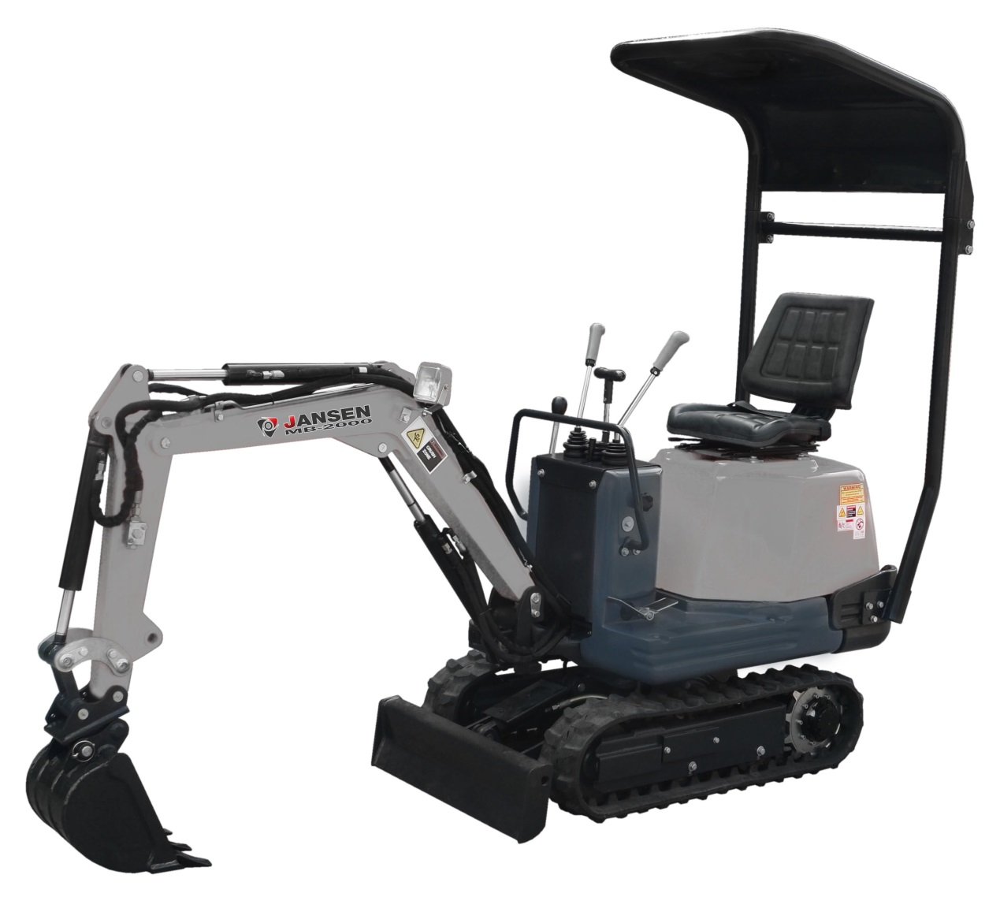

**Instruction & Assembly Manual**

**Jansen GmbH & Co.KG, Muehlenstr. 50, 49824 Emlichheim, Germany tel.: 0049-5943-1881, fax: 0049-5943-1421, email: info@jansen-versand.com**

**Safety Precautions**

The operator shall understand and follow relevant national and local safety laws and regulations. Safety precautions stated herein apply to conditions for which there are no applicable national and local safety laws and regulations.

Accidents occurring during machine operation, maintenance and repair are frequently caused by failure to observe basic safety rules and precautions. Recognition of possible hazards in advance can avoid accidents in most cases.

Make sure to read and understand all protection measures and warnings prior to operation, maintenance and repair of the machine.

Basic safety measures are described in the section “Safety” herein and where there are hazards during operation. Warning signs are also mounted on the machine to identify the special hazardous positions and failure to notify them will cause injuries and deaths of oneself or others. Such warnings are indicated with graphic symbols in this manual and on the warning signs of the machine.

As we cannot predict all possible hazards, warnings proposed in this manual and on the machine are not all inclusive. When programs, tools, operating methods or operation techniques other than those we recommend are adopted, you must make sure they are safe for yourself and others and at the same time ensure the selected operating method or maintenance program will not damage the machine or cause dangers.

**Warning!**

Improper operation, maintenance and repair are all dangerous and may cause injuries and deaths.

Do not operate the machine unless you have read and understood this manual.

Do not maintain or repair the machine unless you have read and understood this manual.

**Contents**

Safety Precautions

Contents

Foreword

Technical Performance and Parameters 1

I. Overview 2

II. Technical parameters 3

Operation and Maintenance 5

I. Machine instrumentation and buttons 5

II. New machine running-in 10

III. Operations 11

IV. Oil, grease, liquid and water supply 27

V. Inspection and maintenance 30

VI. Storage 34

Safety 37

I. Safety rules 39

II. Safe operations 41

III. Safe startup 43

IV. Safe travel 45

V. Safe work 46

VI. Safe stop 47

VII. Safety inspection and maintenance 49

VIII. Safe transport 57

Common Faults and Troubleshooting 59

I. Power system 59

II. Working hydraulic system 60

III. Electrical system 61

**předmluva**

Tato příručka, jako průvodce správným provozem a údržbou stroje, popisuje především možné problémy, s nimiž se můžete při běžném provozu a údržbě stroje setkat, a navrhuje efektivní řešení problémů, a tím pomáhá při účinném provozu. Proto si pečlivě přečtěte tuto příručku před spuštěním a provozem stroje nebo před pravidelnou údržbou.

Tato příručka se týká technického výkonu a parametrů, provozu a údržby, bezpečnosti a běžných poruch a odstraňování problémů. Před spuštěním se ujistěte, že jste získali nejnovější materiály, protože design produktu je neustále aktualizován a konfigurace se liší pro různé uživatele. Chcete-li získat nejnovější materiály, obraťte se na určené prodejce.

V části „Technický výkon a parametry“ jsou uvedeny aplikace, funkce, celková konfigurace, celkové rozměry a parametry.

V části „Provoz a údržba“ jsou popsány základní provozní postupy a pokyny pro každodenní údržbu a jejich účelem je seznámit operátory se správnými postupy inspekce, uvedení do provozu, provozu a odstavení a cyklu údržby.

V části „Bezpečnost“ jsou uvedeny bezpečnostní problémy, které musí být oznámeny během provozu, každodenní údržby a opravy stroje.

V části „Běžné chyby a řešení problémů“ jsou uvedeny běžné chyby, které se vyskytují v pracovním procesu a odstraňování problémů.

Neustále zlepšujeme naše výrobky a zvyšujeme jejich účinnost úpravou jejich designu. Vyhrazujeme si právo neuplatňovat tato vylepšení na prodávané produkty.

Vyhrazujeme si právo na změnu parametrů, zařízení a jejich provozních a údržbových pokynů bez předchozího upozornění**.**

**Technický výkon a parametry**

**Kresba geometrických rozměrů**



## přehled

* Logo vozidla
* Typový štítek produktu je upevněn na přední straně levého krytu. Každý stroj je dodáván s certifikátem kvality. Zkontrolujte prosím certifikát a další dodané dokumenty.
* Aplikace
* Vzhledem k jeho velkým výhodám v komunálním inženýrství, dopravě a dalších stavebních pracích se tento bagr rychle rozvíjel. Vztahuje se na nakládku a vykládku, buldozer, výkop, zvedání, tah a další operace v infrastruktuře, v podnicích a v zemědělství. Jedná se o víceúčelový efektivní strojírenský stroj.
* Vynikající výkon:
* Rozměry Kompaktní rozměry, vysoce flexibilní, vhodné pro provoz v malých prostorech.
* Požadavky na pracovní prostředí:
*  Nadmořská výška: ≤ 2000 m;
*  okolní teplota: -15 ° C ~ 40 ° C (nastavitelný rozsah podle přijatých opatření);
* Rypadlo Tento bagr je běžným strojním zařízením a není vhodný pro hořlavé nebo výbušné podmínky nebo tam, kde je nadměrný prach nebo jedovaté plyny.
* Zakázané operace:
*  přetížení;
*  Závěsné závěsy přímo zavěste na zuby vědra a zvedněte těžké předměty;
* Excav Výkop nad strojem provádějte zvednutím kbelíku.

## II. Technické parametry

Hlavní parametry

Celkové rozměry (DxŠxV) 2429 × 704 × 1186 (mm)

   Celková hmotnost (včetně gumových drah) 0,68 t

   Standardní objem lžíce 0,015 m3

   Kopací síla lopaty 5,2 KN

   Vykopávací síla tyče 3,3 KN

   Maximální tažná síla 8KN

   Úhel vychýlení výložníku (RH / LH) 73 ° / 50 °

   Rychlost jízdy 1,32 km / h

   Stoupatelnost 58% (30 °)

   Kontaktní tlak na zem 25,2 kpa

   Rychlost otáčení 8,5 ot / min

Motor:

Model Yanmar L70N6

Typ vertikální, čtyřdobý, vzduchem chlazený, přímé vstřikování

Výtlak 0,320 L.

Jmenovitý výkon / jmenovité otáčky 4,9 kW / 3600 ot / min

Válcový otvor č. Válce x zdvih 1-78 × 67

Halvní čerpadlo

Type 2 zubová čerpadla

průtok 2×2.5L/min

tlak 19Mpa

capacity olejových nádrží

palivová nádrž 3.5L

hydraulická olej.nádrž 7.5L

provozní hodnoty

Maximum výška kopu 2144mm

Maximum zdvih 1461mm

Maximum hloubka kopu 1288mm

Maximum poloměr kopání 2458mm

Maximum kopací rozah na úrovni země 2389mm

Poloměr kopání při maximální výšce kopání 1666mm

Minimum poloměr otáčení 1133mm

Maximum hloubka kopání shrnovače 151mm

Maximum výška zdvihu shrnovače 141mm

Dimenzní parametry

Rozpětí kola 792 mm

Šířka stopy 150 mm

Šířka podvozku 691 mm

Vnější šířka plošiny 704 mm

Světlá výška plošiny 146 mm

# Provoz a údržba

## I. Strojní vybavení a tlačítka

Řídicí systém mini rýpadla Jansen MB-2000 je pečlivě navržen tak, aby vám nabídl přátelské a pohodlné provozní prostředí.

Nejprve se seznámíme s následujícími položkami:

● Klíč: Mini rypadlo Jansen MB-2000 má dvě klávesy (klávesy pro spínání motoru)

● Pozice ovládacích prvků a přístrojového vybavení (viz obrázek 1)

● Ovládací prvky (viz obrázek 2)

Joy Dozerový joystick (viz obrázek 3)

Joy Pákový ovladač kbelíku / výložníku válce (viz obrázek 4)

● Joystick pro cestování (viz obrázek 5)

Joy Pákový ovladač s otočným / lepícím válečkem (viz obrázek 6)

Steering Pedály řízení na nejvyšší platformě (viz obrázek 7)

Switch Spínač startování motoru (viz obrázek 8)

**Pozice ovládacích prvků a přístrojů**

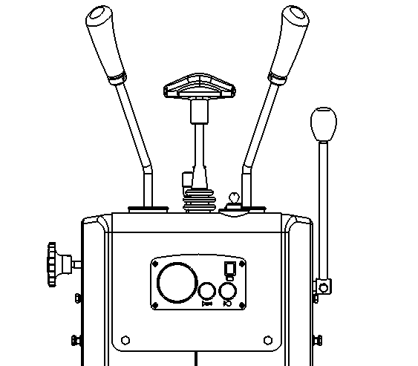

4

3

11

1

10

9

8

7

6

5

2

Obrázek 1 Ovládací prvky a přístroje

1. Dozerový joystick 2. Pákový ovladač kbelíku / výložníku

                 3. Joystick pojezdu 4. Joystick uzamykacího mechanismu

                 5. Joystick joysticku s otočným / nalepovacím válečkem 6.joystikový akcelerátor

                 7. Počítadlo provozních hodin 8. Spínač houkačky

                 9. Spínač pracovní lampy 10. Indikátor nabíjení-vybití

                 11. Spusťte spínač

POLOHA OVLÁDACÍCH PRVKŮ

Pákový ovladač joysticku s otočným / lepícím válcem

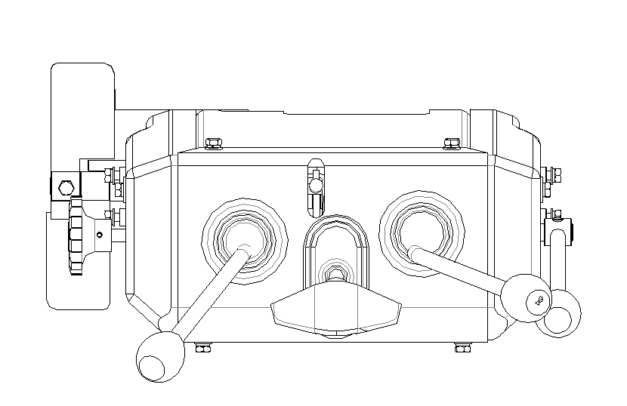

Tlačítko pro změnu provozního režimu

joystick dozer / hlavní rameno

volanty pro přídavnou řídicí jednotku, např. zemní vrták

Joystic jízdy

Pákový ovladač lžíce s válcem / výložníkem

Obrázek 2 Ovládací prvky

Joystik shrnovače

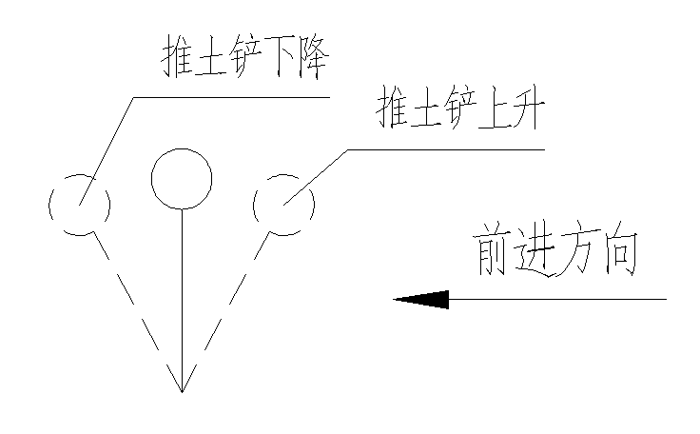

Směr jízdy

Dozer nahoru

Dozer dolů

Obrázek 3 Dozerový joystick

Pákový ovladač lžíce s válcem / výložníkem

Výložník dolů

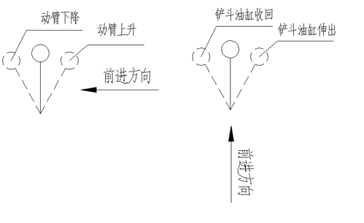

Výložník nahoru

Směr jízdy

Lžíce ven

Lžíce zpět

Směr jízdy

Obrázek 4 Joystick pákového válce / ramene válce

Ovládání jízdy - joystik

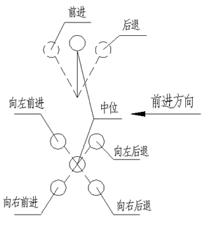

Vpřed na levou stranu

Vpřed na pravou stranu

Zpět dozadu

Zpět dozadu

Směr jízdy

Neutral

vzad

vpřed

joystick s otočným / tyčovým válcem

Výložník doleva

Zvednout tyč

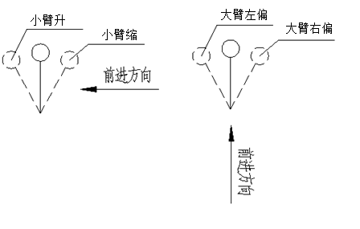

Směr jízdy

Tyč zasunout

Výložník doprava

Směr jízdy

pedály řízení pro další řídicí jednotku (např. zemní vrták)

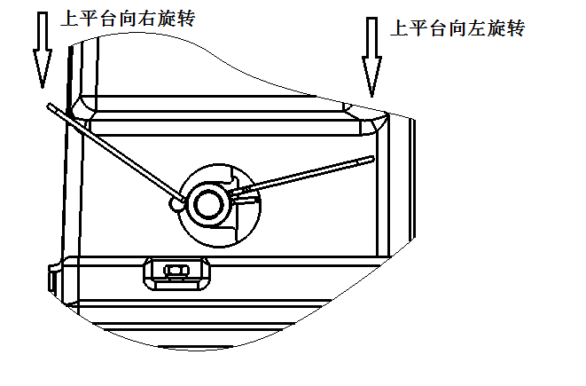

Horní plošina směřuje doleva

Horní plošina se řídí doprava

Obrázek 7 Řídicí pedály pro přídavnou řídicí jednotku

Spínací skříňka motoru

Neutral

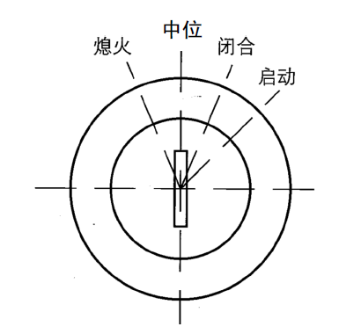

dělání

Start

zapalování

Obrázek 8 – spínání motoru

## 

## II. Zahájení nového stroje

## Před opuštěním továrny byl stroj zkontrolován a seřízen. Používání nového stroje ve špatných pracovních podmínkách po jeho obdržení však výrazně zkrátí jeho životnost. Z tohoto důvodu musí být během prvních 60 hodin proveden nový záběh stroje a během provozu je třeba věnovat pozornost údržbě. Pro záběh musí být dodržena tato pravidla:

##  Spusťte stroj a nechte jej běžet po dobu 5 minut, aby se motor zahřál.

## During Náhlé zrychlení motoru není dovoleno během zahřívání.

##  Pro záběry se upřednostňují volné materiály a zatížení nesmí být příliš vysoké. Během záběhu nesmí vytěžená hmotnost překročit 70% jmenovité hmotnosti a rychlost pojezdu nesmí překročit 70% maximální jmenovité rychlosti.

##  Dávejte pozor na jeho mazání a vyměňte nebo přidejte mazací olej podle plánu.

##  Zkontrolujte těsnost bot a ořechů každé součásti.

● Po záběhu do 10 hodin nebo po dokončení proveďte následující práce:

Pozor!

1. Zkontrolujte podmínky všech šroubů, matic a upevňovacích prvků každé součásti, zejména šroubů krytu válce dieselového motoru, šroubů pro připojení motoru, ventilu a čerpadla atd.

2. Vyměňte hrubé a sekundární filtry motorového oleje a palivový filtr.

3. Vyměňte filtrační vložku hydraulického oleje.

4. Zkontrolujte těsnost vývodů baterie.

5. Zkontrolujte těsnost hydraulického systému.

6. Zkontrolujte připojení a fixaci každého joysticku.

7. Zkontrolujte teplotu a podmínky připojení součástí elektrického systému, stav napájení motoru a pracovní podmínky svítících lamp.

## 

## III. Operations

Startup

**Overall inspection before startup**

* Turn on the steer locking mechanism and set it to the unlocked position to enable steering of the vehicle.
* Check the bottom and periphery of the vehicle for loose bolts, dirt, oil leaks, broken parts and other conditions. Check conditions of the attachments and hydraulic elements.
* Inspection before start:

Attention!

1. Check fuel tank fuel level.

2. Check engine sump oil level.

3. Check sealing of each oil pipe and each component.

4. Check battery wiring.

5. Check hydraulic oil tank oil level.

6. Check sealing of hydraulic system pipeline and peripheral components.

7. Check whether each joystick is flexible and in the neutral position.

8. Check seat belt connection.

Start the engine when you have confirmed each component is in good condition.

1. Startup of the engine

The engine of the machine adopts electrical starting and cable accelerator for flameout. Please note this during operation.

**Precautions:**

Attention!

* Make sure to set all joysticks of the excavator to the neutral position and the switch in the original position before starting the engine.
* Do not set the accelerator to the maximum value at the instant of startup, to avoid damaging diesel engine components.
* Observe the correct procedure to start the engine.
* Adjust the position of the seat to guarantee comfortable driving and operation.
* For other operations of the diesel engine, see the supplied diesel engine document.

**Procedure to start the engine**

Procedure

* Set all joysticks to the neutral position.
* Turn the start key clockwise to the power position to connect the power supply; slightly pull the accelerator cable, turn the key clockwise to the start position and the engine can be started. The starting time shall not exceed 5-10s each time (the continuous working time of the starting motor shall not exceed 15s).
* If start fails and restart is required, there shall be an interval of over 1min. If start fails for three consecutive times, the cause shall be identified and the fault eliminated before restart.
* When it is started, let the engine idle at 600-750rpm for 5-10min and carefully check whether the instruments work properly.

2. After engine startup

* With the engine running at a low speed, check whether the charge-discharge indicator is lit and if so, check whether the charge-discharge line comes loose.
* To quickly raise temperature of the hydraulic elements, cyclically operate joysticks of the working mechanisms to circulate the preheated hydraulic oil in the hydraulic cylinders and hydraulic pipeline.
* Let the diesel engine idle for 5-10min after startup.

**Afterwards, check the following items before the vehicle starts:**

Attention!

1. Whether each switch, lamp, horn and joystick are in good condition.

2. Whether any system has leakage.

3. Whether the engine drive system produces abnormal sound.

4. Whether the working mechanisms are good.

Do not turn the start key rightward to the “Start” position before engine flameout.

Travel

To prevent accidents, sound the horn for warning and ensure there is no miscellaneous personnel onboard or around it and the vehicle is under control at all times before traveling.

* Lift the boom, turn the bucket forward and maintain the travel posture.
* Control the travel speed by pushing or pulling the travel joystick.
* Push the travel joystick and the machine travels forward; pull it backward and the machine travels backward; push it rightward and the machine turns right; push it leftward and the machine turns left; pull it to the right rear and the machine turns right and travels backward; pull it to the left rear and the machine turns left and travels backward.
* To decelerate during traveling forward, you only need to reduce the pushing range of the travel joystick.

Stop

1. Stop procedure

* Set the travel joystick to the neutral position and release the cable accelerator.
* Lower the bucket and other working mechanisms to the ground and lay them flat.
* When the vehicle stops completely, pull up the joystick self-locking mechanism.

2. Engine stop procedure

* Let the engine idle at low speed for approx. 5min for even cooling of all components.
* Rotate and release the cable accelerator switch.
* Remove and properly keep the key and cover the waterproof cover.

3. Get off the excavator

* Watch your steps when getting off. Do not jump down.
* Check the engine unit for accumulated debris and if any, promptly remove it to prevent fire.
* Remove all flammables around the vehicle to prevent fire.

4. The following work must be conducted every day when the work is done:

Attention!

* Check remaining fuel level.
* Check engine sump oil level and cleanliness; if oil level is excessively high and the oil becomes thin, locate and eliminate the reason.
* Check each oil pipe and each component for leakage.
* Check whether the working mechanisms are working properly.
* Inject grease as required to each lubricating point of the working mechanisms.
* Check bolts and nuts of each component for loose ones.
* Clean soil and sundries on the surface and in the bucket of the machine.

**Operation**

**1. Major functions**

Excavation

Loading

Leveling

Ditching

Pipe laying

Grabbing

Demolition

**2. Precautions on proper operation**

* Know surrounding obstacles and terrain fairly well during rotary operation, in order for safe operation;
* Confirm front and rear of the tracks during operation, to avoid tipping or collision;
* Do not face the final drive toward the excavation direction as far as possible, or the travel motor or hose may get easily damaged;
* Ensure the left and right tracks are in complete contact with the ground during operation, to improve dynamic stability of the overall machine.

**3. Correct operating method**

**A: Excavation**

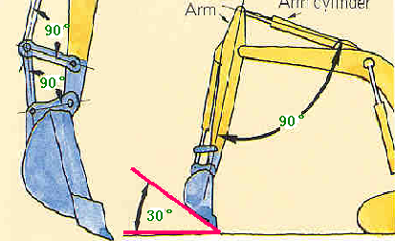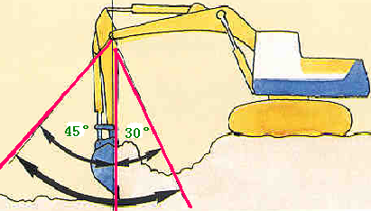

◎ The digging force is the highest when the bucket cylinder and linkage as well as the stick cylinder and stick form an angle of 90°. When the angle between bucket teeth and the ground is 30°, the digging force is optimal since the soil cutting resistance is the smallest.

◎ For excavation with the stick, ensure it travels forward within 45° and backward within 30°. Moreover, the use of boom and bucket can improve the digging efficiency.

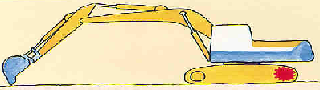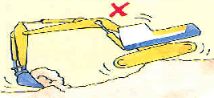

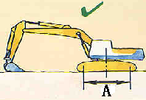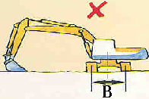

* Machine stability during operation can not only enhance operating efficiency and extend its service life but also ensure safe operation (stop the machine on relatively flat ground);
* Do not dig soil out of the safety angle under the machine during digging, since it will cause the machine to tip.
* The driving wheels at the rear can ensure good stability and prevent strike on final drive by external forces.
* Since track distance A on the ground is always larger than distance B, forward operation ensures high stability. Please avoid lateral operation.

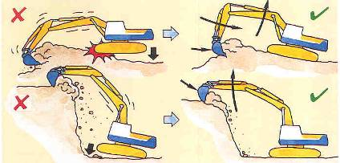

* Excavation by aid of vehicle weight will cause improper stress of the slewing bearing and strong undercarriage vibration and impact, so the hydraulic cylinders shall be utilized for excavation.
* Correct operating method: retract the stick and raise the boom while moving the bucket; the combination of these three actions makes perfect excavation, but the travel power shall not be used for excavation.

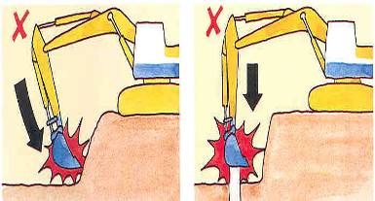

* Knocking operation will easily cause early damage of the bucket and working mechanisms and weld failure and produce instantaneous high pressure internal the cylinders which will severely damage the cylinders or hydraulic pipeline.

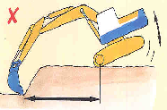

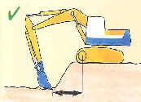

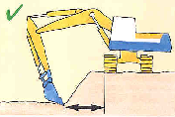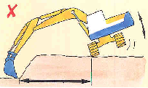

* Keep the dig point close to the machine to enhance stability and digging force; dig point away from the machine will cause the gravity center to shift forward, thus resulting in instability.
* Since lateral excavation is featured with poor stability as compared with forward digging and the dig point away from the vehicle center will intensify machine instability, proper distance shall be maintained between the dig point and the vehicle center to ensure efficient and stable operation.

**B: Efficient rock excavation**

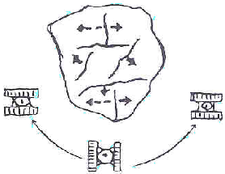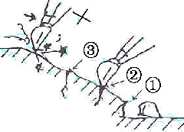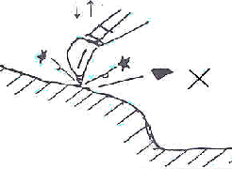

* Avoid rock excavation with the bucket, or it will cause severe damage of the machine;
* Adjust the vehicle orientation according to the rock crack direction, to let the bucket smoothly get inside for digging; insert the bucket teeth into the rock crack and dig with the power of the stick and the bucket (note slippage of bucket teeth);
* For big rocks without cracks, crush them first and then dig with the bucket.

**C: Leveling operation**

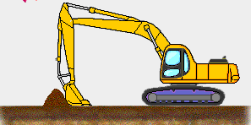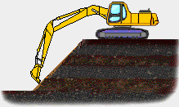

* For leveling operation, set the machine on the flat ground to prevent it from shaking.
* Control of boom and stick coordination and their speed is of critical importance for flat surface conditioning.

(1) When the vehicle operates on flat ground:

When the ground is bumpy, the vehicle will shake, so excavation shall be done after leveling the ground.

(2) Adjustment of distance between the vehicle and the flat ground

It is easy to work between A and B, so it requires adjustment.

(3) Leveling of ground higher than the machine:

When leveling a slope, remove the uneven section (convex) left by the first shovel at the second shovel; there shall be overlap when eliminating the uneven section left by the first shovel and the overlap width is 20cm (the uneven section) +1/3 bucket width.

(4) The vehicle starts working (digging)

When the vehicle starts digging, ground leveling is a key point.

Control is difficult when the boom and the stick work simultaneously, since adjustment of their speed is critically important for leveling operations.

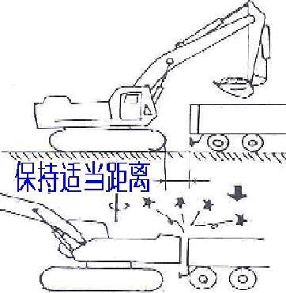**D: Loading operation**

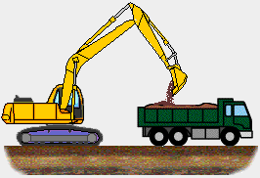

Keep proper distance

The vehicle shall stop stably on a horizontal plane, or accurate control of swing and unloading will be difficult, thus extending the operation cycle time.

To unload materials onto a dump truck, wait for the truck to stop stably and the driver to leave before swinging the bucket and unloading.

Proper distance shall be kept between the vehicle and the dump truck, to prevent the rear of the vehicle from colliding with the truck when it swings for 180°.

Load soil by turning left as far as possible to ensure wide view and high operating efficiency; properly control the rotation angle to reduce time required for swing.

When the dump truck is lower than the excavator, the time to raise the boom can be reduced and the vision improved.

For loading and unloading of rocks and other heavy materials, load first sand and gravels before big rocks; unloading shall be conducted close to the bottom of the truck and unloading at a high level is not allowed, to reduce impact damage of the dump truck.

As a general rule, load the dump truck starting from its front and move backward, so that you can clearly see the bucket unloading conditions.

**E: Operation on soft foundation**

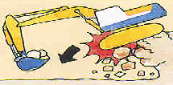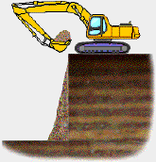

For operation on soft land, you shall understand looseness of the soil and limit digging range of the bucket, to prevent landslide, collapse and other accidents as well as vehicle sink.

**F: Underwater operation**

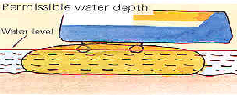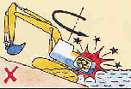

Attention shall be paid to permissible water depth of the vehicle in underwater operation (the water level shall be below the idler center. Excessively high water level will cause poor lubrication of slewing bearing due to water ingress, broken engine fan blades due to water impact and electrical element short circuit or broken circuit due to water ingress.

**G: Hoisting operation**

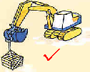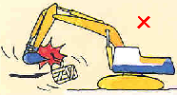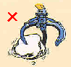

The use of hydraulic excavators for hoisting is generally prohibited. Frequent use of them as cranes on site can easily cause accidents. Attention shall be paid to safe operation.

When a hydraulic excavator is used for hoisting, surrounding conditions of the site shall be confirmed and high-strength hooks and steel ropes shall be used and special hoisting devices shall be used as far as possible.

Hoisting operation shall be conducted slowly; the lifting ropes shall be of proper length, since excessively long ropes will cause the object to swing severely and make it difficult to control.

The hook angle will change and the steel ropes will swing outward when the boom and the stick work in combination; please properly adjust the bucket position.

Misoperation or hurry operation will cause many potential hazards. Please stay away from the object to avoid danger when the object to be lifted is fastened.

**H: Handling of excavator trapped in mud**

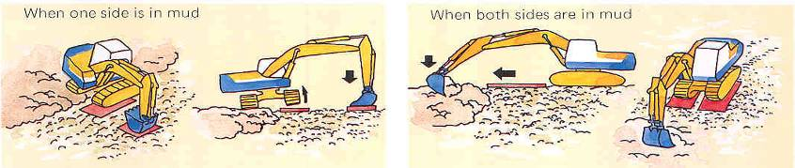

When the track is trapped deep in mud, set a wood plate below the bucket to prop up the track, then set a wood plate under the track and drive the vehicle out of the mud.

**I: Correct cylinder operation**

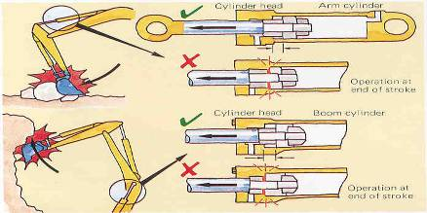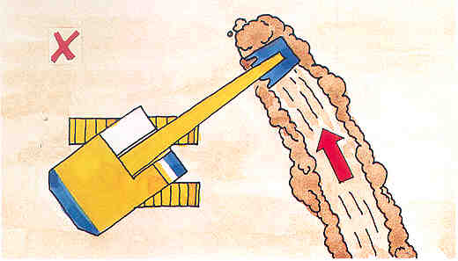

There is a buffer mounted inside the cylinder which can gradually release the backpressure when getting close to the end of the stroke; if it suffers impact load at the stroke end, the piston will directly hit the cylinder head or bottom, easily causing cylinder breakage, so clearance shall be reserved at the stroke end as far as possible.

Bulldozing by aid of swing operation will cause improper stress of bucket and working mechanisms, thus causing distortion or crack failure and even broken hinge pin, so such operation shall be avoided as far as possible.

**Correct traveling operation**

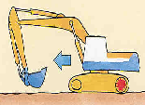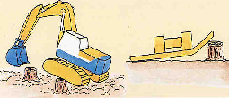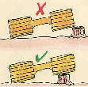

To move the excavator, the driver shall first observe and sound the horn before moving it, to avoid accidents due to people around; its position after movement shall ensure there are no obstacles within swing radius of the excavator and unprofessional operation is prohibited.

The road conditions shall be identified before travel, for instance, detection with the bucket and avoidance of rocks, stubs and other bumps during traveling.

During traveling, withdraw the working mechanisms close to the vehicle center as far as possible to maintain stability.

Set the final drive to the rear to protect it.

Avoid stubs, rocks and other obstacles during driving as far as possible to prevent track distortion; if you must run over the obstacles, ensure the track center runs on the obstacle center.

Do not try to move the machine upward or downward at an angle of over 35°. Operation in mountainous regions will include even 70° climbing in actual work; here you must operate carefully, since the insurance company probably will reject the claims once rollover accidents occur. Properly fasten the seat belt and set the bucket to the traveling direction uphill or downhill and approx. 0.5-1m above the ground. If it runs off track, go back the same way. Turning on the slope is prohibited.

For road transportation, local laws and regulations shall be observed, trailer and excavator conditions well understood and the transport route studied. During transportation, the posture for parking shall be noted and the boom shall not exceed the height of the cab to avoid damaging the boom.

**Uphill and downhill operations**

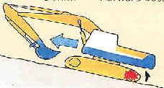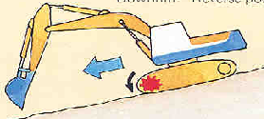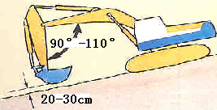

To travel uphill, the driving wheels shall be at the back to increase adhesion of tracks in contact with the ground.

To travel downhill, the driving wheels shall be at the front to tighten the upper tracks, to prevent the vehicle from sliding forward due to gravity and the dangers thus caused.

For traveling on the slope, the posture of the working mechanisms shall be as shown in the figures to ensure safety; when it is stopped, the bucket shall be slightly inserted into the ground and blocks placed below the tracks.

For traveling and turning on the slope, it shall be slowed down; the left track shall turn backward to turn left and the right track turn backward to turn right, thus reducing the dangers during turning on the slope.

Operation in cold weather

**Precautions for operation at low temperature**

It will be difficult to start the engine at excessively low temperature. Hence, the following points shall be satisfied:

Use fuel, hydraulic oil and lubricating oil of low viscosity. See the oil category and brand table for the specific oil brands.

Precautions for battery operation

Attention!

* Battery capacity falls as ambient temperature drops. Since low battery charging rate will result in frozen electrolyte, approx. 100% charging rate shall be kept and the battery insulated as far as possible, so that the engine can easily get started the next day.
* If the battery is frozen, do not charge it or start the engine. Heat the battery to 15°C, or it may explode.
* Highly cold-resistant batteries shall be used for operations in alpine regions.

**Precautions at the end of every day’s work**

The following work shall be properly done to prevent freezing of mud, water or snow sticking to the machine from affecting its startup the next day:

Attention!

* Thoroughly remove mud, water and snow on the machine, to prevent them from entering, freezing and consequently damaging sealing elements.
* Stop the vehicle on dry and hard ground. If impossible, stop it on wood plates, since they can prevent freezing of the vehicle into the ground and facilitate startup the next day.
* Since battery capacity falls significantly at low temperature, it shall be covered or moved to a warm place and mounted again the next day before work.

**When cold weather has passed**

As the season changes and the weather turns warm, the following work shall be conducted:

Replace all oils and greases with new fuel, hydraulic oil and lubricating oil (or grease).

## IV. Oil, grease, liquid and water supply

Precautions:

Attention!

* The oils must be clean and the diesel engine experience 72h sedimentation; cleanliness of the hydraulic system must reach 18/15 (GB/T14039-1993) or NAS10 (US standard), or it will easily cause bucket drop or excessive pump wear.
* The oiler and the oiling point must be clean, to prevent water and dirt from entering the oil.
* The machine must be horizontal for oil level inspection.
* At different ambient temperatures, oils of different viscosity and brand shall be used. Please strictly follow the oil brand table.
* Different oils shall not mix or substitute each other, or it will cause ageing of rubber elements and premature part wear.
* Make sure to check for oil leaks after oil filling or change.

Filling method

**1. Filling of hydraulic oil tank**

(1) Oil level check

Check liquid level of operating oil tank and it shall be above the center line of the oil level indicator. Replenish if it is insufficient.

Attention!

For oil level check, the bucket shall be laid on the ground horizontally and the engine stopped.

(2) Engine oil change

Follow the procedure below:

* Lift the boom to the highest point and let the boom fall and the bucket rotate by aid of their own weight, thereby completely drain oil inside the oil cylinder.
* Release the drain plug at the bottom of the oil tank to drain the sump oil while the oil is still warm.
* Remove the blank flange and clean the interior of the oil tank, the filling port and filters at suction and return ports. Replace damaged filters.
* Retighten the blank flange and drain plug.
* Add new oil through the filling port until the center line of the oil level indicator. Do not inject oil into the tank by directly removing the filter at the filling port.
* With new oil added, let the engine run at low speed and operate the working mechanisms several times to exhaust air in the system. Now the oil level will fall slightly. Please check it again (above the oil level indicator center line) and replenish if necessary.

(3) Discharge of sundries

Water and sundries accumulating in the oil tank can be discharged via the drain plug.

**2. Fuel tank fuel supply**

(1) Fuel level check

Check the fuel level on the oil level indicator from the outside of the fuel tank.

(2) Discharge of sundries

Drain water and sundries accumulating in the fuel tank via the discharge flange at the bottom. Besides, clean the filling and suction port filters and replace damaged ones.

**3. Engine oil supply**

(1) Oil level check

Take the dipstick out, wipe its tip, insert and take it out again to check the oil level.

It is good if the oil level is between the upper and lower lines; if it is below the lower level, add until it reaches the upper line.

Oil level check must be conducted before work or approx. 15min after the engine is stopped.

Then, check the oil for dirt and sundries and change the seriously polluted oil.

(2) Oil change

Drain the oil via the drain plug of the engine sump and fill new oil via the filling port to the upper line.

Let the engine run at low speed, stop it and check the oil level. If insufficient, add oil to the upper line.

Do not go beyond the upper line during oil change.

Engine oil change must be conducted when the engine is still hot.

**4. Grease injection**

Grease injection points cover all shaft liners and shafts, including

* Shaft liners of the working mechanisms;
* Top platform and hinged seat pin bush;
* Pin sleeves at both ends of all cylinders;
* Control lever bearings;
* Traveling wheel bearings.

**Oil category and brand table**

|  |  |  |  |  |
| --- | --- | --- | --- | --- |
| Category | Description | | Application Point | Amount |
|  | Summer oil | Winter oil |  |  |
| Fuel | 0# diesel | -20# or -10# diesel | Fuel tank | 3.5L |
| Engine oil | 10W-30 or 15W-40 | | Diesel engine | 1.1L |
| Grease | 3# or 4# calcium-based lubricating grease | | Bearings, working mechanism pins, cylinder pins, etc. | 4kg |

## V. Inspection and maintenance

**Routine inspection and maintenance are critical for efficient machines. The point that properly working machines do not require inspection and maintenance is wrong.**

**Proper inspection and maintenance can both extend service life of the machine and promptly identify and eliminate the faults, thus reducing repair time and costs.**

**1. Maintenance items when a new machine has worked for 250h**

1) Replace diesel filter.

2) Replace engine sump lubricating oil, engine lubricating oil filter and bypass filter (if any).

3) Check engine valve clearance and if it is nonconforming, adjust.   
**2. Daily maintenance items**1) Check, clean and replace air filter element. First, directly purge the filter element interior along the seam with compressed air of <700kPa; then purge it along the external seam and finally purge it from the inside. It is recommended to replace the filter element every 500h. Do not use filter element with broken folds or seal. Do not replace or clean air filter element when the engine is working. Do not knock it when cleaning the filter element.

2) Check and tighten track shoe bolts.  
3) Check and adjust track tension. Set a plate on top of the track and check the maximum sag of at the middle. It shall be approx. 10-20mm; if not, adjust with the tensioning bolt.   
4) Replace bucket teeth.  
5) Adjust bucket gap: When the gap is smaller than thickness of one gasket (gasket thickness: 1mm or 2mm), do not make any adjustment.   
6) Replace oil filter element.   
**3. Maintenance items before engine startup**  
1) Check engine sump oil level and replenish if necessary.  
2) Check diesel oil level and add via the filling port if it is not within the specified range.  
3) Check hydraulic oil tank oil level and add if necessary.  
4) Check cleanliness of the air filter. Clean or replace air filter element if there is dirt.  
5) Check whether the electrical system fuses are damaged and whether there is short or broken circuit; tighten loose electrical elements and joints; carefully check the battery, the starter motor and the generator and remove flammable sundries around the battery.  
6) Check bucket lubrication and promptly add grease.  
**4. Every 100h maintenance items**  
1) Lubricate the following positions:  
a. Boom hydraulic cylinder pin (x1)   
b. Boom hinge pin (x2)  
c. Stick connecting pin (x1)

d. Stick hydraulic cylinder connecting pin (x1)

e. Bucket connecting pin (x2)  
f. Top platform-hinged seat connecting pin (x1)  
g. Dozer hydraulic cylinder connecting pin (x2)  
 Lubricating points producing abnormal noise must be lubricated despite the lubrication interval. For new machines, the above points must be lubricated every 10h during the first 100h.   
2) Water and sundries in the diesel tank, if any, shall be discharged via the drain valve at the bottom. Trichloride shall not be used for cleaning the inside of the tank.   
**5. Every 250h maintenance items**  
1) Replace engine sump lubricating oil and engine lubricating oil filter. Lubricating oil and lubricating oil filter must be replaced when the excavator has worked for 6 months but less than 250h; similarly, they must be replaced when the excavator has worked for 250h but less than 6 months.   
2) Replace hydraulic oil tank return oil filter.   
3) Lubricate lubricating points (x2) of the slewing bearing.  
**6. Every 500h maintenance items**Every 100h and every 250h maintenance items shall all be implemented.  
1) Replace diesel oil filter.   
2) Check swing pinion grease and add if insufficient. Insert a steel rule into the grease to check grease depth where the pinion passes and it shall be ≥28mm.   
3) Replace engine sump lubricating oil and engine lubricating oil filter.  
4) Replace filter element at air vent of the hydraulic oil tank.   
**7. Every 1000h maintenance items**Every 100h, every 250h and every 500h maintenance items shall all be implemented.  
1) Replace oil in swing gear reducer.   
2) Check all fasteners. Designate professional staff to deal with it.  
**8. Every 2000h maintenance items**

**Every 100h, every 250h, every 500h and every 1000h maintenance items shall all be implemented.**1) Replace hydraulic oil in hydraulic oil tank and clean the coarse filter (suction filter).

With hydraulic oil replaced, exhaust air in the pipeline by following the procedure below:   
a. Exhaust the air through the hydraulic pump bleed plug: when there is oil coming out, tighten the plug.  
b. Exhaust air in the hydraulic cylinders: let the engine run at low speed and each hydraulic cylinder work for 4-5 cycles.   
c. Exhaust air in the swing motor: let the engine run at low speed, release the bleed plug for exhausting and tighten the plug when there is oil coming out. Do not operate the swing mechanism during exhausting, since air not exhausted in the swing motor may damage motor bearings.   
d. Exhaust air in the travel motor (conducted only after motor case oil drain is finished).  
2) Clean engine vent.  
3) Check the generator and the starter motor. Ask professional staff to repair it if the brush is worn or bearing grease fails. Check once every 1000h if the engine is started frequently.  
4) Check and adjust engine valve clearance.   
5) Check dampers. Damper rubber elements shall have no cracks or peeling on the surface.   
**9. Every 4000h maintenance items**Every 100h, every 250h, every 500h, every 1000h and every 2000h maintenance items shall all be implemented.  
Check the water pump for oil and water leaks and the drainage port for blockage.  
**10. Maintenance for long-term storage of excavator**1) Clean and dry each component and store it in a dry building. When it can only be stored outdoors, stop the machine on well-drained cement ground and cover it with tarpaulin.   
2) Fill the diesel oil tank, lubricate each position and replace the hydraulic oil and lubricating oil before storage.  
3) Apply a thin layer of grease onto the hydraulic tank piston rod.  
4) Remove the battery negative terminal wire and cover the battery or remove it from the machine and separately store it.  
5) Lock the joysticks and pedals with pedal locks for safety lock bars.   
6) Set shutoff valves of attachments to the locked position and mount plugs on the elbows.  
7) Set selector valves of the attachments to the position of “out of service”.  
8) Start the engine once every month and drive for a certain distance to form new oil film on the surface of moving parts and components and charge the battery; let the air conditioner, if any, generate cooling air for 3-5min.

## VI. Storage

**Before storage**

For long-term storage of the excavator, operate according to the procedure below:

Clean each part of the vehicle, dry them in the air and store them in dry warehouse. If the vehicle can only be stored outdoors, stop it on well-drained concrete ground and cover it with canvas.

Fill the fuel tank, add grease and replace hydraulic oil before storage.

Apply a thin layer of grease onto exposed section of the hydraulic cylinder piston rod.

Remove the battery negative terminal and cover the battery case cover, or remove the battery from the vehicle and separately store it.

Set all joysticks to the neutral position.

**During storage**

**1. Daily storage**

With the bucket horizontal on the ground, stop the vehicle at a flat place and an indoor dry place is preferred. For outdoor storage, cover it with canvas.

Set the start switch to “OFF” and remove and properly keep the key.

With the key removed, slightly operate the working mechanism joysticks 2-3 times to eliminate residual pressure in the oil cylinders and hoses and then set them to the neutral position.

Lock all parts with locks.

**2. Long-term storage**

There is short-term storage with a period not exceeding two months and long-term storage with a period of over two months. The excavator storage site shall be sheltered, well ventilated and dry without hazardous substances or gases. Wax shall be sprayed onto machine surface for rust prevention before long-term storage.

**Shutdown for one month:**

The following items shall be implemented in additions to the precautions for “daily storage”:

* Start and drive the vehicle and operate the working mechanisms every week to get prepared for immediate use.

**Shutdown for over one month:**

The following items shall be implemented in additions to the precautions for “daily storage”:

* Check each oiling point for specified oil.
* Considering the rainfall in rainy seasons, stop it on high hard surface as far as possible.
* Remove the battery.
* For places featured with summer heat or damp, the battery shall be stored in another dry place even in the case of indoor storage and charged every month.
* Cover components (breather and air filter) facing moisture ingress with canvas.
* Check every week whether the vehicle can be started by starting and fully warming up the engine and driving the vehicle forward and backward for a certain distance. To operate the working mechanisms, you shall first remove the grease applied on the piston rods and when operation is finished, apply a thin layer of grease again.

Attention!

To apply rust inhibitor indoor, open the doors and windows for proper ventilation and elimination of toxic gases.

**Use after long-term storage**

Remove the covers for damp prevention.

Remove grease applied on exposed parts.

Drain oil in engine crankcase and fill new oil.

Remove engine cylinder head, fill oil into the valves and rocker shaft assembly and check action of each valve.

Charge and then mount the removed battery and connect it to the cable.

Conduct checks before operation.

Add grease to each hinge joint.

# Safety

Jansen MB-2000 excavator profile drawing and component names

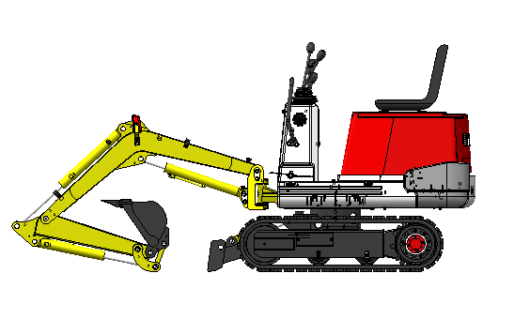

Stick assembly

Boom assembly

Headlamp

Left counterweight

Left cover

Undercarriage

Dozer

Bucket

Right counterweight

Operator station

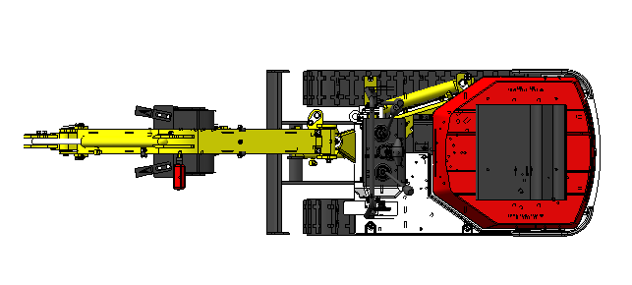

Safety signs and their positions

Safety signs are stuck to certain parts of the machine. Carefully read and observe the instructions on all safety signs. This section introduces the positions and design of these safety signs.

Properly keep the safety signs. Promptly replace or repair in the case of missing or damaged safety signs or unclear texts or graphics. For replacement of parts with safety signs, ensure the new parts have corresponding safety signs.

To clean the safety signs, use cloth and soap water, etc. Do not use detergent or gasoline, etc.

Safety signs

Keep Away! Oil tank label

On the counterweights On the hydraulic oil tank

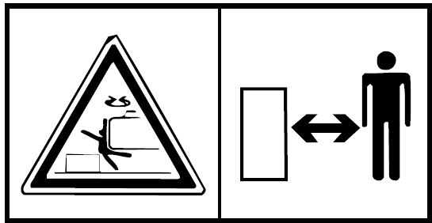 

Hydraulic Oil Tank

Do not touch the engine! Do not get close to the boom (or bucket)!

On both sides of the hood On both sides of the boom

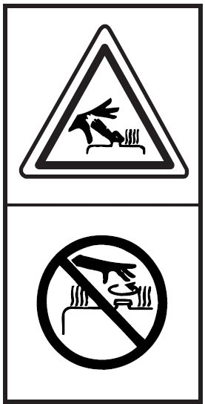 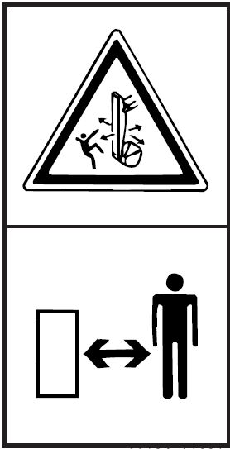

## I. Safety rules

Safety code

Noise limit

Sound power level of radiated noise shall comply with the following requirements (according to ISO6393: 1998):

Engine power P (kW) Sound power level dB(A)

P≤70 ≤106

70<P≤160 ≤108

70<P≤160 ≤113

Noise at the driver’s seat shall not exceed 85dB(A) (ISO6393: 1998).

Electromagnetic compatibility

Electromagnetic compatibility of the machine shall comply with relevant requirements of IEC61000. It shall work properly in the environment under certain electromagnetism and the electromagnetism it produces during work shall not cause harm to the surrounding environment.

Safety requirements

Frequently condition your body. Do not operate the machine when you are in poor shape. Do not operate the machine when you feel uncomfortable, feel sleepy after taking medicine or have drunk wine, since your mistakes will cause harm to yourself and others in such cases.

Thoroughly understand the various rules and regulations for operation, master all signals used during work and promptly know the meaning of various signal flags, signals and signs as soon as you see them.

When the operator works together with the commander, ensure all staff understand the sign language used.

Personal protective equipment

For operation or maintenance of the machine, the required personal protective equipment shall be determined based on the specific work, for instance, hard safety helmet and safety goggles, safety shoes, reflective vest, mask, earplugs, gloves, etc.

To throw metal chips and minor debris, and, in particular, to hammer pins or remove sundries from the air filter with compressed air, make sure to wear safety goggles, hard helmet and thick gloves.

Do not loose clothes, or they may get drawn into the control system or other moving parts, causing serious injuries or even death.

Do not wear greasy clothes, in order to prevent catching fire.

As compressed air may cause personal injuries, wear mask and safety clothes and shoes when compressed air is used for cleaning and the compressed air for cleaning shall have a maximum pressure lower than 0.3MPa.

Check whether all protective equipment functions properly before use.

Unauthorized refit

Any refit unauthorized by Jansen GmbH & Co.KG may cause dangers.

Please consult Jansen GmbH & Co.KG or its designated dealers before refit.

For any damages caused by unauthorized refit, Jansen GmbH & Co.KG shall bear no responsibility.

## II. Safe operations

Understand the machine

* Only authorized personnel can operate and repair the machine.
* Know well and observe all safety regulations, precautions and instructions for operation and maintenance of the machine.
* Learn the materials supplied with the machine and understand construction, operation and maintenance of the machine as well as the positions and functions of various buttons, handles, instruments, alarm devices and other components of the machine.
* Thoroughly understand the various rules and regulations for operation and all signals used during work.
* Oil or grease adhering to the operating position and around may be slippery and must be promptly wiped off.
* Carry out the various checks before and after operation, for instance, check whether all safety protection devices are safe. Ignorance of oil, water and air leaks, deformation, looseness, abnormal sound and other abnormalities may cause faults and serious accidents, so inspection must be regularly conducted.

Get on and off the machine

* Check the handrails or steps before getting on or off and promptly remove oil stains, lubricant or mud, if any, to prevent slip during getting on or off.
* Do not jump on or off the machine. Do not get on or off when the machine is moving.
* To get on or off, face the machine, pull the handrails, step on the steps and maintain three-point contact (both feet and one hand or both hands and one foot) to ensure body stability.
* Do not grab any joystick while getting on or off.
* Do not climb up or down the machine while taking tools or other items. The required tools or items shall be placed on the platform first.

Fire prevention

* Fuel, lubricating oil and other materials used for engine of the excavator are flammable and it is dangerous to get close to smoke and fire. Hence, attention must be paid to the following points:
* Keep flames away from the above combustible liquids.
* Shut down the engine and do not smoke or get close to open fire during fuel filling.
* Tighten tank covers of all abovementioned combustible liquids.
* Store the above combustible liquids in containers with corresponding labels, place them in a safe place and store by category, to prevent use by nonprofessional staff.
* Thoroughly remove combustible materials stacking on the machine, such as fuel, lubricating oil or other debris, and ensure there is no tarpaulin or other inflammables.
* Electric welding or flame cutting of combustible liquid pipes is not allowed. They shall be cleaned with non-flammable liquid detergent before electric welding or cutting.
* If the muffler exhaust port is close to withered grass, old paper or other inflammables during work, you must be especially careful.
* To stop the vehicle, pay attention to the surrounding environment and such places where there is no withered grass, old paper or other inflammables near the muffler and other hot parts and components shall be selected.
* Check for fuel, engine oil and hydraulic oil leaks and if any, promptly repair or replace the component and thoroughly clean it after repair before work.
* As explosive gases may be generated near the battery, do not get close to smoke or fire. Strictly follow the product instructions to maintain, repair and use the battery.
* Check the dark regions, but no open flame (match, lighter, etc.) shall be used.

Prevention of run-over injury or severed limb

* Do not enter or set your hands, arms or any other body parts between the moving parts, for instance between the operating mechanisms and the cylinders, between the machine and the operating mechanisms, etc. Since space at the linkage mechanism increases or decreases as the operating mechanisms move, proximity to them can cause serious accidents or personal injuries. If you need to get inside, make sure to shut down the engine and lock the operating mechanism.
* Properly support the equipment or attachments when working under the machine. Do not use hydraulic cylinders for support, since the attachments will fall if the control mechanism moves or the hydraulic pipeline leaks.
* Unless otherwise specified, do not make any adjustment when the machine is running or the engine is started.
* Keep away from all rotary and moving parts.
* To conduct inspection and maintenance with the machine started is quite dangerous and not allowed in principle.

## III. Safe startup

**Driver’s clothing**

The driver shall select required personal protective equipment according to job demand. For instance, wear helmet, work clothes with tight cuffs and legs, safety shoes, safety goggles, gloves, masks, etc.

**Understand ambient environment before starting the machine**

* Understand ambient environment and carefully check for abnormalities that may cause dangers before work.
* Check the landform and ground conditions of the work site and determine the optimal and safest working method.
* Make the ground solid and level as far as possible before work.
* To work on the street, there shall be specially assigned people to direct the traffic or barriers established and “No Entry” sign attached around the work site, to protect pedestrians and vehicles.
* To work indoor or in enclosed places, ensure effective ventilation to avoid toxic effects of the waste gas.
* For places with buried facilities such as water pipes, gas pipes and high-voltage cable ducts, the competent department or company shall be contacted to determine their positions, thus preventing damage of such facilities during construction and ensuring construction safety.
* To work underwater or in swampy areas or to pass through sand embankment, first check the ground conditions, the water depth and water flow. Do not go beyond the permitted water depth. Check the lubricating oil filling port when work is done.

**Inspection prior to startup**

Carefully check the machine every day before startup and persistently implement daily maintenance. Abnormalities found shall be promptly reported to the managerial staff and operation shall not start unless repair is done.

* Check the machine for oil, water and air leaks, loose bolts, abnormal sound, broken or missing parts and other faults.
* Check the fuel level and engine sump oil level. Check the air filter for blockage.
* Check all lighting and signal lamps and promptly repair faulty ones, if any.
* Check whether all instruments are functioning properly and whether joysticks are in the stop position.
* No parts or tools shall be left around the driver’s seat, since they may fall and damage the machine due to vibration generated during traveling and operation.
* Set the driver’s seat to the position facilitating operation. Check whether seat belt and belt fasteners are damaged. The seat belt must be replaced when it has been used for three years.
* Completely remove grease on the handrails and steps and sludge on your shoes to prevent slip while getting on and off and avoid affecting operations.

**Machine startup**

Check whether there is any person on, below or near the machine before getting on and remind them to leave. Do not start the machine if they have not left.

* Do not start the engine if the warning sign “No Operation” is stuck to the joystick.
* First seat properly, adjust the seat to facilitate easy operation and then fasten the seat belt.
* Get familiarized with warning devices, instruments and control mechanisms on the instrument panel.
* Sound the horn to warn people around to leave.
* Start the engine according to the operation instructions.
* The engine can only be started in the driver’s cab. Do not start the engine by short circuiting the starter motor, since start of the system with the bypass circuit will damage electrical system of the machine and such operation is quite dangerous.

**Inspection after startup**

Conduct the inspection below after the machine is started but not operated, to confirm there are no safety hazards.

* Check whether there is abnormal sound or vibration while the engine is running; if any, it indicates the machine has faults and it shall be promptly reported to the managerial staff. Do not operate it unless it is repaired.
* With the machine not operated, check engine speed control.
* Check the instruments and alarm indicators to ensure they can function properly and work within the specified range.
* Operate all joysticks to ensure they move flexibly.

## IV. Safe travel

**Note safety of yourself and others**

* To ensure personal safety of every one, develop good operation habits.
* Sound the horn to give the signal and confirm it is safe before starting driving.
* In particular, confirm there are no people or obstacles around.
* Do not get distracted, look around or be absentminded during operation, since one moment of negligence may cause great misfortunes. Pay special attention to the driving direction and people working around. Sound the horn for alarm in the case of danger.
* Since it is dangerous to carry other people onboard, do not let anyone except the driver get on.
* Do not use the dozer as a working platform or to carry people.

**Precautions for travel in harsh environment**

Take care when working or driving in harsh environment. Do not work alone in dangerous places. Ground conditions, bridge strength, topographic and geological features of the work site shall be studied in advance.

Soil piled up on the ground and near the ditches is soft and may collapse due to weight or vibration of the machine, thus causing tipping of the machine.

Avoid getting close to the cliff or deep ditches, since such places may collapse due to weight and vibration of the machine, thus causing machine tipping and casualty.

For continuous operation in rainy days, you must be careful since the working environment changes before and during the rain. Be especially careful with operations after earthquake or blasting, since there is debris piling on the ground.

## V. Safe work

**Keep good operation habits**

* Always stay in the seat, fasten the seat belt and wear personal protective equipment during operation.
* Joysticks of working mechanisms require accurate operation. Safe and accurate operations are required and misoperation shall be avoided.
* Carefully check for faults and faults, if any, shall be promptly eliminated. Parts in operation cannot be repaired.
* First travel to the object to be excavated, confirm the surrounding conditions and then proceed with the work.
* Work shall stop in the case of poor visibility due to smoke, fog or dust, etc. If the work site is dark, lighting equipment must be mounted.

**Take care of surrounding conditions**

* No unconcerned person shall enter the work zone. The working mechanisms rise and fall, turn left and right and moves forward and backward, it is dangerous to get near the machine.
* For operation on the kerb, cliff or places that may collapse, measures shall be taken to ensure safety and a superintendent assigned to give the command.
* To unload soil or rocks from a high level, sufficient attention shall be paid to safety of the drop point.

**Do not get close to dangerous places**

* Muffler exhaust gas directed toward flammables or exhaust pipe close to flammables can easily cause fire. Hence, special attention shall be paid to places where there is oil, grease, withered grass, chemicals or other dangerous or flammable substances.

**Do not get close to high-voltage cables**

* Do not get the machine in contact with overhead cables, since even proximity to high-voltage cables can cause electric shock.

## VI. Safe stop

**Note safety of yourself and others**

* The machine shall be stopped on flat ground as far as possible and the working mechanisms lowered to the ground and set horizontal.
* Do not stop on the slope. If necessary, the slope shall be <20%, wedges shall be placed under the tracks to prevent the machine from moving and then the working mechanisms lowered to the ground and set horizontal.
* To stop the vehicle, unload all materials on the ground, lower the bucket completely onto the ground and set it horizontal, set all joysticks to the neutral position and lock them with locking devices, if any. Shut down the engine, lock all equipment with the key and remove the key. To get off, face the machine and slowly climb down. Do not jump down.

Danger!

Do not get on or off the machine while it is traveling.

**Precautions for operation in cold regions**

* With the work finished, completely remove water, snow or mud adhering to electric wires, electric wire connectors, switches, sensors and covers of these parts. If they are not removed, their water content will freeze and cause malfunction of the machine the next time it is operated, thus resulting in unexpected faults.
* Warm-up shall be conducted thoroughly. If the machine is not fully warmed up before the joysticks are operated, the machine will respond slowly, thereby causing unexpected accidents.
* If the electrolyte of the battery is frozen, do not charge the battery or start the engine with another power supply, since it is dangerous and may get the battery on fire.
* When the battery is charged or another power supply is used to start the engine, melt the electrolyte of the battery first and then check for leakage before starting the engine.

## VII. Safety inspection and maintenance

**General**

* Personnel that operate and repair the machine shall be properly trained and obtain relevant qualifications. People not involved in the on-going maintenance and repair work shall not enter the work zone. If necessary, assign a special person to guard it.
* Repair of the vehicle shall follow the corresponding procedure. If you have no idea how to deal with it, please ask Jansen GmbH & Co.KG for help.
* To repair the vehicle or assemble and disassemble the components, a commander to control such operations shall be determined in advance and the operational procedures prepared in order for step-by-step operations.
* Working clothes with tight cuffs and legs and safety goggles shall be worn.
* Please use the correct repair tools. No damaged or poor quality tools shall be used.
* Strictly observe the instructions on the signs. For matters of special importance, signs are attached to the vehicle and the instructions on these signs shall be followed. If the signs are found missing or polluted, the relevant signs shall be added or cleaned.
* Before proceeding with the repair work, labels indicating “No Operation” or other similar warning labels shall be stuck onto the start switch and the instrument panel, to prevent other people from starting the engine or operate the joysticks. Failure to observe this may cause injury or death of the operators.
* A responsible person shall be assigned prior to removal or installation of the parts and components.
* The fuel and engine oil are hazardous materials and fuel, engine oil, lubricating grease and oil cloth shall not come in contact with any open fire or flame.
* Smoking is prohibited during oil filling or power supply inspection.
* Parts and components removed from the machine shall be stored in a safe place and ensure they will not drop down. Establish railings around and hang the sign “No Entry” to prevent proximity of personnel without permission.
* No people other than the workers involved shall get close to the machine or parts and components.
* The surrounding regions of the work site shall be kept clean and neat, without scattered tarpaulin, lubricating oil (grease) or other materials, to prevent fire or fall of the personnel.

**Work in enclosed places**

* Since waste gas produced by the engine can cause disease or death, you need to adopt an exhaust unit to exhaust waste gas in the region if you need to start the engine in an enclosed place. Doors shall be opened for ventilation in the absence of exhausting devices.

**Work under the machine**

* Stop the machine on a solid flat ground. Make sure to lower all working mechanisms to the ground and lay them flat before proceeding with maintenance or repair work under the machine.
* Do not work under a machine that is not properly supported.
* Fix the tracks with wedges.

**Maintenance operations during running of the engine**

* Do not carry out maintenance work while the engine is running, in order to prevent injuries. If maintenance is required while the engine is running, the following precautions shall be observed.
* There shall be a worker assigned to stay in the driver’s seat and get prepared to shut down the engine at any time. All workers must keep in touch with each other.
* Do not touch the exhaust pipe, the muffler or other high-temperature components to prevent scald.
* There is the danger of getting drawn into the rotary parts when the point of operation is close to rotary parts. Hence, you must be extremely careful.
* Do not activate any joystick. If you must operate the joysticks, give a signal to other workers to warn them to get to a safe place.
* Do not blindly adjust components you do not know well.

**Do not drop any foreign matter into the machine**

* With the inspection window or oil tank filler port opened for repair, take care not to drop any foreign matter (for instance: nuts, bolts or tools) into the machine, since such objects dropped into the machine will cause damage of the machine, misoperation and other faults. Make sure to take it out if there is any foreign matter dropped into the machine.

**Cleaning**

* The machine shall be promptly cleaned, so as to prevent dirt and mud on the machine from splashing into the eyes and prevent the danger of fall and injuries due to oil stains on the machine.
* Nonflammable detergent shall be used to clean the machine.
* To clean the interior of the machine, shut down the engine, set all joysticks to the neutral position and securely lock the joysticks with locking devices, if any, to prevent movement of the working mechanisms.
* For cleaning of the machine, antiskid shoes shall be worn to avoid slipping on wet surfaces. When high-pressure water is used to rinse the machine, protective clothes shall be worn.
* Do not directly spray water onto elements of the electrical system (for instance: sensors, electrical line connectors), since water getting into the electrical system may cause operation failures.

Attention!

Protective clothes and safety goggles must be worn when compressed air is used to purge the filters.

**Heavy objects**

* Make sure to wear safety goggles, helmet and other protective clothing and insert a copper bar between the hammer and the objected to be hammered when hammer is used.
* If hammer is used to knock hard parts, such as pins or bearings, fragments may splatter into one’s eyes and cause injuries.
* Take care with tools and heavy objects and prevent them from falling down.

**Welding repair**

Electric welding shall be conducted by qualified welders at places fitted with appropriate equipment. Since gases will be generated during electric welding and fire or electric shock may happen during work, no unqualified personnel are allowed to carry out such operation. The following points must be observed for welding work:

* Disconnect the battery terminals to prevent explosion of the battery.
* Remove paint on the position to be welded to prevent the generation of harmful gases.
* Combustible flames and sparks may be generated and there is the danger of fire and explosion when welding work is conducted on hydraulic equipment or pipes or any places near such facilities. Hence, electric welding shall not be conducted at such positions.
* Sparks spattered directly onto rubber hoses, cables or pressurized pipes during electric welding may cause sudden breakage of such pipes and damage of insulating layer of the cables, so they must be covered with fire dampers.
* Protective clothing shall be worn when electric welding is conducted.
* The work site of electric welding shall be well ventilated.
* All inflammable materials shall be removed and the work site shall be equipped with fire extinguishers.
* Modifications that will affect performance, safety and strength of the machine and the working mechanisms shall not be conducted on site.

**Overhaul of hydraulic system**

* The oil cylinders and other hydraulic devices shall be locked, the hydraulic oil cooled down and all system pressure of the hydraulic system released prior to overhaul of the hydraulic system.
* Do not bend or knock on the high-pressure pipes. Do not mount improperly bent or damaged rigid tubes or hoses on the machine.
* Repair all loose or damaged fuel or lubricating oil line as well as rigid pipes and hoses of the hydraulic system. Since leakage may cause fire, please promptly repair or replace them.
* Carefully check the pipeline, rigid pipes and hoses and tighten all joints at specified torque. Do not check for leakage with naked hands, but plates or paper boards shall be used. Pressurized liquid leaks of even a pinhole size can penetrate the muscles and cause personal injuries and deaths. If the solution is sprayed on the skin, a surgeon familiar with treatment of such injuries shall be employed to handle it with several hours. Replace the relevant parts if the problems described below are discovered:

Attention!

1. The joint is damaged or leaks.

2. The hose has worn or split outer layer and exposed reinforcing steel wire.

3. The hose has local bumps.

4. The hose has significant twists or is flattened.

5. Hose reinforcing steel wire gets into the outer layer.

6. End fitting is dislocated.

* Ensure all pipe clips, guard plates and preheating covers are properly mounted, to prevent overheat due to vibration or friction between other parts.
* Replace oil, filters and other parts and components used for the hydraulic system. Appropriate containers shall be selected to store the liquids and the disposal of liquid waste shall comply with local environmental protection laws and regulations.

**Prevention of fire**

* The engine must be shut down and smoking or the proximity of open fire is prohibited when fuel is filled.
* Fuel, lubricating oil or other inflammables shall be stored away from open fire.
* Combustible materials, such as fuel, lubricating oil or other debris, piled up on the machine shall be thoroughly eliminated. Ensure there is no tarpaulin or other inflammables stored on the machine.
* Since explosive gases will be generated around the battery, no smoke or fire shall get close to it. The battery shall be maintained, repaired and used in strict accordance with the product instructions.
* When selecting the place to stop the machine, pay attention to the surrounding environment. In particular, there shall be no such inflammable materials as withered grass or oil paper near the muffler and other high-temperature parts and components.
* Check the fuel, engine oil and hydraulic oil for leaks and replace broken hoses if there is leakage. With repair done, thoroughly clean it before you can proceed with other operations.
* Check the electric cables for electric leakage and replace broken ones.
* Nonflammable solvent shall be used to clean the parts and components and gasoline or other flammable liquids shall not be used.
* Electric welding or flame cutting of pipes or cases that contain combustible liquid is not allowed, but they shall be first thoroughly cleaned with nonflammable detergent before electric welding or cutting can be conducted on them.
* Check whether the fire extinguishers are in good condition, know well the positions of the fire extinguishers and the first-aid kit and know how to use them before proceeding with repair work.
* Check the dark places, but open fire (for instance: match, lighter, etc.) shall not be used.

**Regulations for the filling of fuel and lubricating oil**

As fuel, lubricating oil and hydraulic oil can all be lit by open fire, the following regulations must be observed:

Attention!

* Shut down the engine when fuel or lubricating oil is filled.
* No smoking.
* Overflowing fuel, lubricating oil, hydraulic oil and other liquids shall be promptly wiped off.
* Top covers of all containers for fuel, hydraulic oil and lubricating oil shall be securely tightened.
* The places for filling or storing fuel, hydraulic oil and lubricating oil shall be well ventilated.

**Electrical system**

* The repair and maintenance of the electrical system shall be carried out by qualified professional staff.
* When you need to adjust the external power supply, connect the cables in the last, in order to prevent explosion caused by sparks generated around the battery.
* Make sure to remove the key to the starter switch prior to repair of the electrical system.

**Charging of the battery**

If the battery is not properly handled when it is charged, the battery may explode. Hence, the relevant regulations for charging of the battery covered in the battery handling procedure and instructions shall be implemented and the precautions specified blow shall also be observed:

Attention!

* Charging shall be conducted in a well-ventilated place and the battery cover removed, thereby preventing diffusion of the hydrogen and the explosion it may cause.
* Set the voltage of the charger equivalent to the voltage of the battery to be charged. Wrong voltage setting will cause the charger to get overheated and catch fire and it may even cause explosion.
* Connect the positive (+) charging chuck of the charger to the positive (+) terminal of the battery and the negative (-) charging chuck to the negative (-) terminal of the battery. Make sure to securely tighten these two terminals.
* If the charging rate of the battery is below 1/10, carry out fast charge and set the value to below the rated capacity of the battery. Excessively high charging current may result in leakage or evaporation of the electrolyte, which may further cause a fire or explosion.

**Waste materials**

To prevent pollution, especially where there are people or animals living there, the following regulations must be observed:

* Do not pour waste oil into the sewer, rivers or other places.
* Store the oil drained from the machine in containers. Do not drain the oil directly onto the ground.
* Relevant laws and regulations shall be observed when such hazardous substances as lubricating oil, lubricating grease, fuel and battery are to be handled.

## VIII. Safe transport

**Loading and unloading of the excavator**

* There are always potential dangers in the loading and unloading of the excavator and you must be extremely cautious. When the excavator boards a vehicle (or ship) by itself, the engine shall run at a low speed and the excavator shall also travel at a low speed.
* Loading and unloading of the excavator shall be carried out on solid flat ground and a safe distance kept from the edge of the road.
* For loading and unloading of the excavator, the wheels of the transport vehicle shall always be fixed to ensure the transport vehicle will not move and cushion blocks shall be set under the ramp.
* Plates of sufficient strength shall be used and the plates shall be wide and long enough, in order to provide a slope for safe loading and unloading. The angle between the plates and the ground shall not exceed 15° and the distance between the plates shall match the distance between tracks of the excavator.
* Make sure the plates are securely fixed and positioned, with the height of both sides being the same.
* Make sure the surface of the plates is clean, without lubricant, oil stains, ice or loose materials.
* Do not turn on the plates. If necessary, the excavator shall leave the plates, properly adjust the direction and then travel onto the plates.
* With the excavator loaded onto the transport vehicle, securely lock the steering mechanism with a dead lever, fix the tracks of the excavator with wedges and fasten and fix it with ropes that are strong enough, to prevent the excavator from moving during the transport process.

**Road transport**

* When a trailer is used to tow the excavator, mass, height and width requirements specified in relevant national and local laws shall be satisfied and all relevant traffic laws shall be observed.
* The mass, height and length of the excavator shall be taken into account when the transport route is determined.
* When it crosses a bridge or pass through a building on a private property, it shall be checked first whether they are strong enough to support the weight of the excavator. When it runs on public roads, it shall first comply with and observe relevant regulations.
* When other modes of transport are considered, it may require disassembling the machine.

The preventive measures for operation, maintenance and safe operation rules given in this manual applies to the applications specified for this machine. If you go beyond the specified scope of application shown in this manual, Jansen GmbH & Co.KG bears no safety responsibilities and safety of such operations shall be undertaken by the user. Do not carry out operations prohibited in this manual in whatever case.

# Common Faults and Troubleshooting

## I. Power system

|  |  |  |
| --- | --- | --- |
| Fault | Cause(s) | Troubleshooting |
| 1. The overall machine is not actuated although the diesel engine is running. | 1) The joystick is not operated.  2) The joystick locking mechanism is not released.  3) There is a lack of hydraulic oil.  4) The pump breaks down.  5) The multi-way valve is broken.  6) The oil pressure is excessively low. | 1) Operate the joystick again.  2) Release the joystick locking mechanism.  3) Replenish the oil to the specified level.  4) Overhaul the gear pump.  5) Overhaul the multi-way valve.  6) See fault 2. |
| 2. The oil pressure of the transmission is excessively low. | 1) The main relief valve fails.  2) The pipeline is leaking.  3) The oil pump fails.  4) The filter is blocked.  5) The oil seal of the oil cylinder is leaking seriously. | 1) Overhaul the multi-way valve.  2) Tighten the pipe joints.  3) Replace the oil pump.  4) Replace the filter element or replace the filter.  5) Replace the oil seal and the oil seal seat. |
| 3. The driving power is not strong enough. | 1) There is a lack of hydraulic oil or there are oil leaks.  2) The diesel engine is not functioning properly.  3) The temperature of the hydraulic oil is excessively high.  4) The hydraulic oil pressure is excessively low. | 1) Overhaul and then add new oil.  2) Overhaul the diesel engine.  3) See fault 4.  4) See fault 2. |
| 4. The travel motor is overheated. | 1) The hydraulic oil is insufficient or there are oil leaks.  2) The oil is too dirty is deteriorates.  3) It has worked continuously for too long time or it is overloaded. | 1) Check the oil level as required and adjust it.  2) Replace the oil.  3) Temporarily stop the motor to cool it down and avoid overload. |

## II. Working hydraulic system

|  |  |  |
| --- | --- | --- |
| Fault | Cause(s) | Troubleshooting |
| 1. The power to lift the boom or the power to swing the bucket is insufficient. | 1) The oil cylinder is leaking inside or the oil seal is worn or damaged.  2) The distributing valve is excessively worn and the fit clearance between the valve stem and the valve body exceeds the specified value.  3) The pipeline system has oil leaks.  4) The gear pump has serious interior leakage.  5) The relief valve is not properly adjusted or the system pressure is low.  6) The oil suction pipe and the oil filter are blocked. | 1) Replace the oil seal.  2) Disassemble and repair the valve to make the clearance comply with the specified value or replace the distributing valve and the valve stem.  3) Locate and eliminate the oil leaks.  4) Replace the gear pump.  5) Set the system working pressure to the specified value.  6) Clean the oil filter and replace the oil. |
| 2. The bucket rotates slowly or the boom is lifted slowly while the engine is running at a high speed. | The multi-way valve gets stuck. | Disassemble and check the multi-way valve. |
| 3. The working pressure is insufficient. | 1) The pressure of the relief valve is set too low.  2) The multi-way valve gets stuck.  3) The pressure adjusting spring is broken.  4) The pump fails.  5) The pipeline pressure loss of the system is excessively high. | 1) Precisely adjust pressure of the relief valve.  2) Disassemble, clean and then remount it.  3) Replace with a new product.  4) Overhaul the pump.  5) Replace the pipeline or adjust the relief valve pressure within the permitted range. |
| 4. The working flow is insufficient. | 1) The oil supply is insufficient.  2) Reversing inside the valve has serious leakage.  A. The oil temperature is excessively high.  B. The hydraulic oil selected is inappropriate. | 1) Check the oil pump.  A. Take measures to reduce the oil temperature.  B. Change the oil. |
| 5. External leakage | The fasteners have come loose. | Tighten relevant fasteners. |

## III. Electrical system

|  |  |  |
| --- | --- | --- |
| Fault | Cause(s) | Troubleshooting |
| 1. The diesel engine won’t start or it is difficult to start it. | 1) The battery is broken or is out of power.  2) The start button or the starting relay is broken.  3) The lubricating oil is too thick.  4) The lines have bad contacts or open circuit.  5) The carbon brush is seriously worn or has bad contact.  6) The electromagnetic switch of the starter motor or the shifting fork is broken.  7) The rotor of the starter motor is burnt out. | 1) Replace or charge the battery.  2) Replace the start button or the starting relay.  3) Replace the lubricating oil.  4) Check and repair.  5) Check and replace.  6) Check whether the coil is intact, whether the contacts are smooth, whether the shifting fork can move flexibly, whether the spring is broken and whether there are other signs of faults and repair them.  7) Replace the starter motor. |
| 2. The instrument is not pointing correctly. | 1) The connecting wires come loose or fall off.  2) The sensor is broken.  3) The instrument is broken. | 1) Tighten the terminals.  2) Replace the sensor.  3) Replace the instrument. |
| 3. The generator is not generating electricity or the charging current is excessively low or high. | 1) The connecting wires of the engine come loose.  2) The belt is loose.  3) The regulator or the generator breaks down. | 1) Retighten the connecting wires.  2) Adjust the belt.  3) Replace with an integrated generator. |
| 4. The lamp is not lit. | 1) The fuse is blown.  2) The filament is burnt out.  3) The connecting wires come off. | 1) Replace the fuse.  2) Replace the bulb.  3) Tighten the terminals. |
| 5. Battery charging fails or the charging current is low. | 1) The connecting line of the positive (+) pole of the generator comes loose.  2) The battery connecting lines are too loose.  3) The generator conveyor belt is excessively loose. | 1) Connect the electric lock but do not start the generator, and the generator positive (+) pole shall have a 24V voltage.  2) Visually check and tighten them.  3) Visually check and tighten it. |
| 6. The battery charging current is excessively high for a long period of time. | 1) The battery is seriously out of power.  2) One or two battery cells are broken or short circuited.  3) The electronic regulator is short circuited or broken. | 1) Start the diesel engine and check the B+ terminal of the generator. If the current is excessively high and the voltage is below 25V, it is the battery that fails.  2) Repair or replace the battery.  3) Replace the regulator. |